KOWTHA & CO., Phone no: 2573440 (O)
Chartered Accountants 9490008968 (M)
26-22-21, MUDUNURIVARI STREET, 9490196072 (M)
GANDHI NAGAR, VIJAYAWADA – 520003.

PROPOSAL NO. | : | 3000144707
DATE OF VISIT & TIME : 11.00AM | : | 25-04-2025

APPLICANT’S DETAIL:
Name of Applicant | : | Mr. XXXX
Name of Co-applicant | : | Mrs. XXXX
About Business
Name of Business | : | XXXXX
Business Address | : | XXXXX
No. of years in the current address | : | 10 years
Constitution of Business | : | Self
Name of other Partners(if it is a partnership concern) | : | Proprietor
Management | : | XXXXX
Contact Number | : | XXXXX
TIN | : | NA
PAN | : | Yes
Certificate of Incorporation | : | -
Documents verified | : | NA
Nature of Business | : | Making and selling of Samos, kachori and Bajji
Main product | : | -
Main Raw material | : | -
Vendors / suppliers to applicant | : | -
Business transaction | : | Cash Basis and some of the transactions found on account transfers.
Stock observed | : | Rs. 3,000/-
If no stocks observed, reason for the same | : | NA
Business activity observed | : | Good business activities was observed at the time of PD.
Main Customers in the business | : | local people
Sales payment terms | : | Cash and bank
GST Registration | : | Nil
ITRs filing | : | Nil
No. of Employees (Co- applicant) | : | Declared by customer: no  Observed :  Salaries: - 01 member
Go down address (if any) | : | No
Other business details (if any) | : | NA

BUSINESS PROFILE :
APPLICANT :

- Applicant has started this business in the year of 2015
- It is sole proprietorship business and applicant is the sole proprietor of this business
- She is running business under the name of M/S.
- He has 20 years of experience in this field.
- The business involves the preparation and sale of snacks such as samosas, kachoris, bajjis, and papads at the premises.
- Various sizes of samosas, kachoris, papads, and bajjis are prepared fresh on-site.
- The pricing is as follows:
- Samosa – Rs. 20 each
- Kachori – Rs. 30 each
- Papad – Rs. 40 each
- He purchases required raw materials stock from Nellore.
- Customers are general public
- He is running business in owned premises and it is a road side business
- He employs one worker under him in the business premises and paying the total salary of Rs.10, 000/- per month.
- He maintains around Rs.3,000/- worth of stock in business premises
- Major business transactions are done through bank in her business

Native Place: Visakhapatnam
Business since: Applicant has started this business from the same premises for the last 10 years.
Previous Experience:- -
Business Premises : Achari street ,Nellore
If Rented:- -Owned
Business Premises in Sq. ft. : -
Market References from:

Vendors contact details: -
Daily Sales / Monthly Sales: Monthly Sales were around Rs. 1,50,000/-
ABOUT PERSONAL DETAILS:- Current Residence: ACHARI STREET ,NELLORE

Family members:
Name Relation Age Business Education

- Rekha Wife 44 years House wife 10th class
- Swasthik Son 6 years - -
- Kunal Son 12 years - -

Sales Bills: NP
Purchase Bills: Not Provided
Neighbour check with name: - NAME & NUMBER
- -
CIBIL Details: NA
Pervious Loans:
- NO LOANS
Banking Details: -- -
Firm Account: - SBI
Savings Account: - Savings account
Assets Details:
- Own house property
Other income: - NA
Business Machinery:- - NA
Observation :
- Applicant is running this business on road side premises.
- Submitted bank statements and udyam registration certificate of the premises
- Observed the UPI screen shots of the premises in the applicant’s mobile phone.
- Applicant is running the business in the same premises for the past 10 years.
- He is running the business on a road side premises.
- UPI scanner is seen in the premises and it is registered under the applicant name.

Status: NE GATIVE

Loan Details
Loan Amount Applied : 20, 00,000/-
Purpose of loan : Renovation of House

Signature of the Assessing Official :____________________

Particulars | Units | Charge | Total
- | - | - | -
- | - | - | -
- | - | - | - | Considered per day @ days
- | - | - | -
- | - | - | -
- | - | - | -
-- | - | - | -
- | - | - | -
- | - | - | -
-- | - | - | -
Daily Gross Income |  |  | -
Labour & Material (Everyday) |  |  | -
Net Income / Day |  |  | -

Applicant’s Monthly Expenses of the business:
Sales : 1, 50,000/-
Purchase : 82,500/-
Rent : -
Salaries/Wages : 10,000/-
Transport Charges : 3,000/-
Electricity Bill :
Other Exp : 10,000/-
Total Expenses : 1, 05, 500/-
Net Profit : 44,500/-
Net Margin : 29.6 %

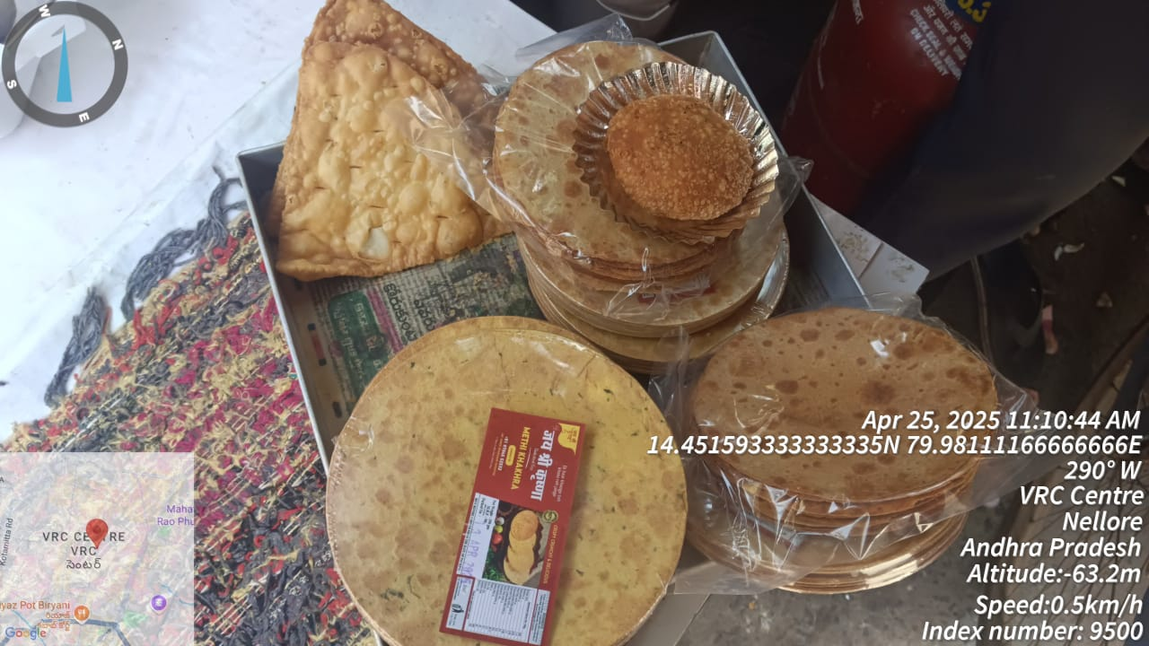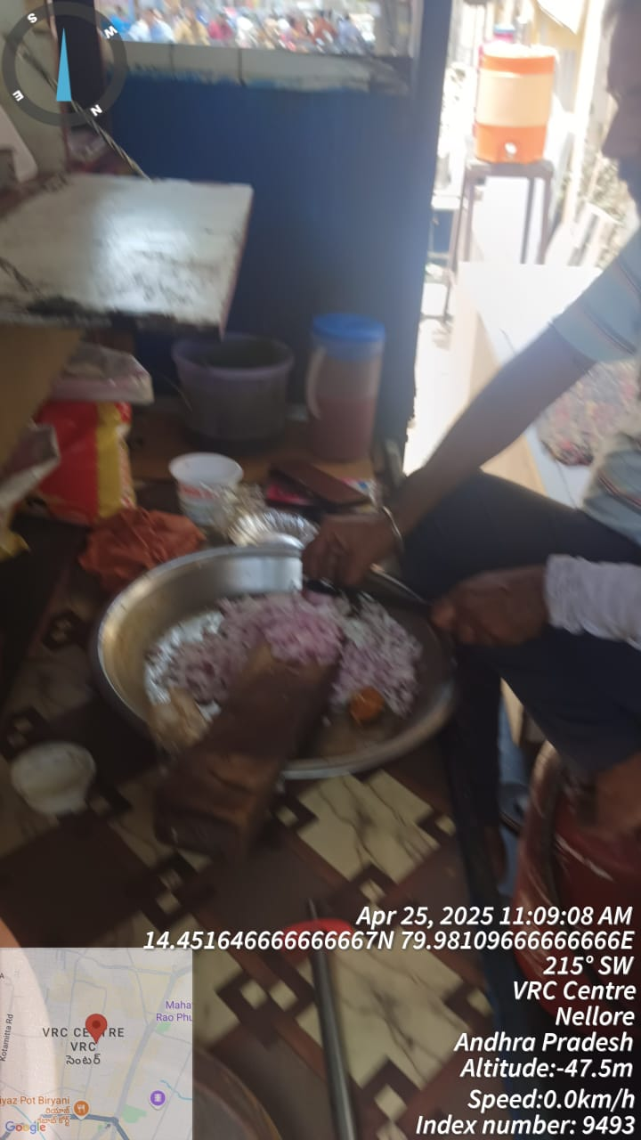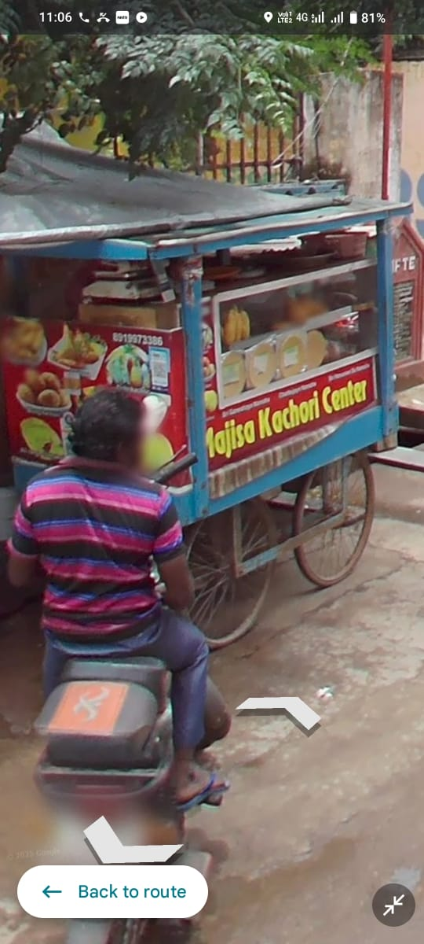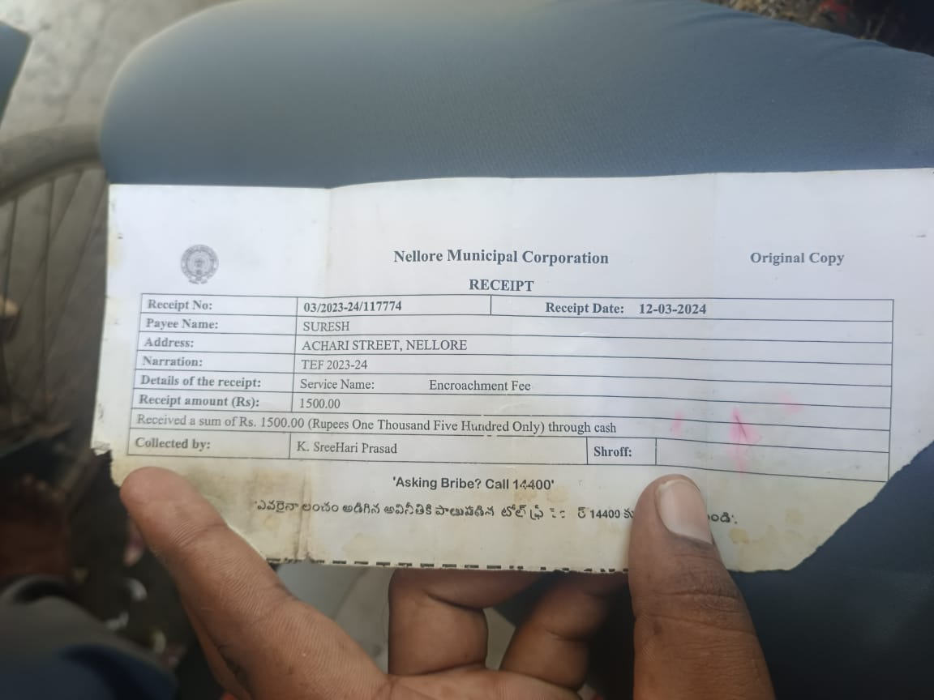

We taken the estimated figures based on customer feedback and the gross profit has been calculated taking into consideration market information gathered on our experience.

Disclaimer clause: - The Report (Including any attachments) has been prepared on the basis of verbal information provided by the person contacted.

ADITYA BIRLA CAPITAL (Aditya Birla Housing Finance Ltd., will be solely responsible for any actions taken on this report and any liabilities directly or indirectly accruing from such actions, our efficient services will not be liable in any case.

For KOWTHA&CO
Chartered Accountants

(K. Venkatasubba Rao)
Partner
Membership No 203320

